1. After pump library changes are made, in the Guardrails Editor, click File 🡪 Properties

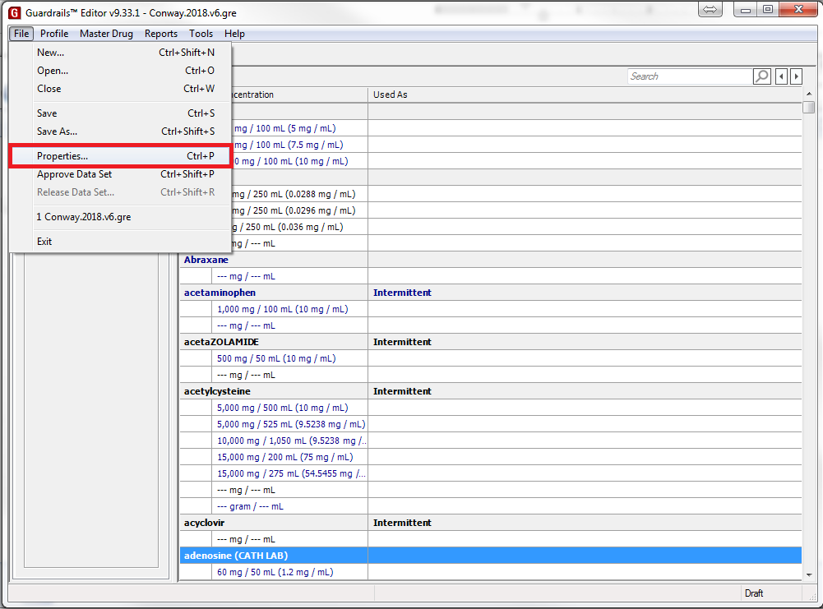

Sidenote: please document changes to the pump library in the Version History.txt that is in the Alaris Pumps folder on the G:\PH\ drive. This allows us to follow changes to the library easier.

1. In the field “Data Set Name”, increment the version number by 1
   1. Naming conventions for the pump libraries are “Conway.YYYY.v#”
      1. Where YYYY is the current year, and # is the version number (ie. Conway.2018.v1)

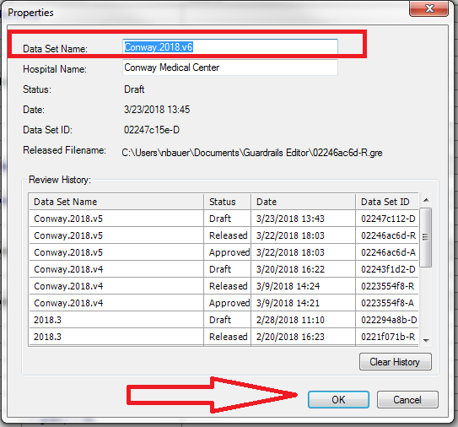

1. Click OK to close the Properties window
2. Hit File🡪Save As…
   1. Save the file with the same naming convention used in Step 2

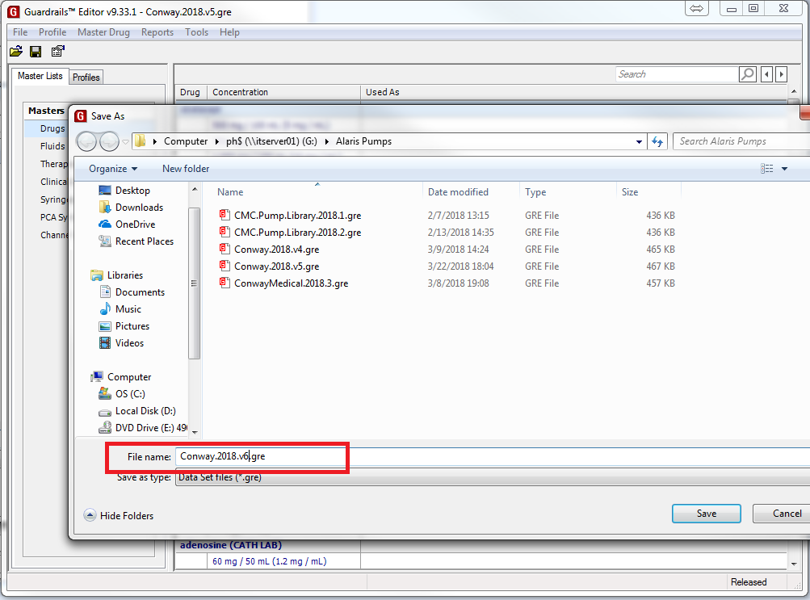

1. Click File🡪Approve Data Set

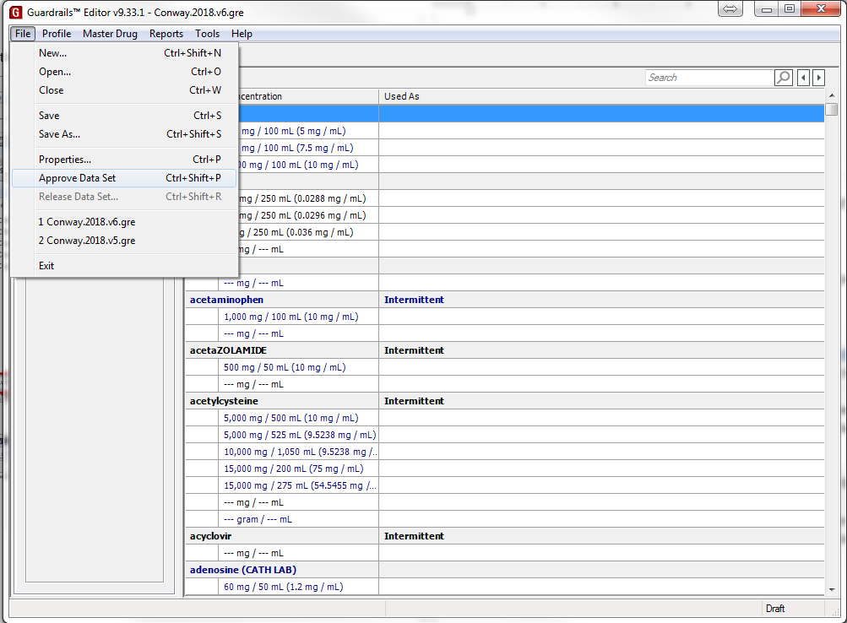

* 1. A report will be generated as a Word document

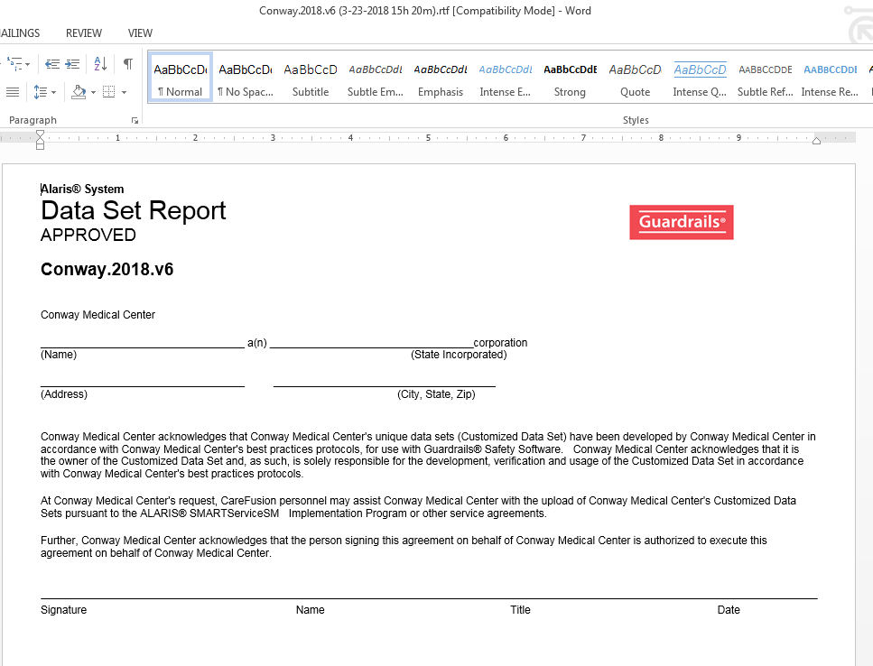

* 1. In Word, click File🡪Save As
     1. Click Browse to pick a spot to save the file

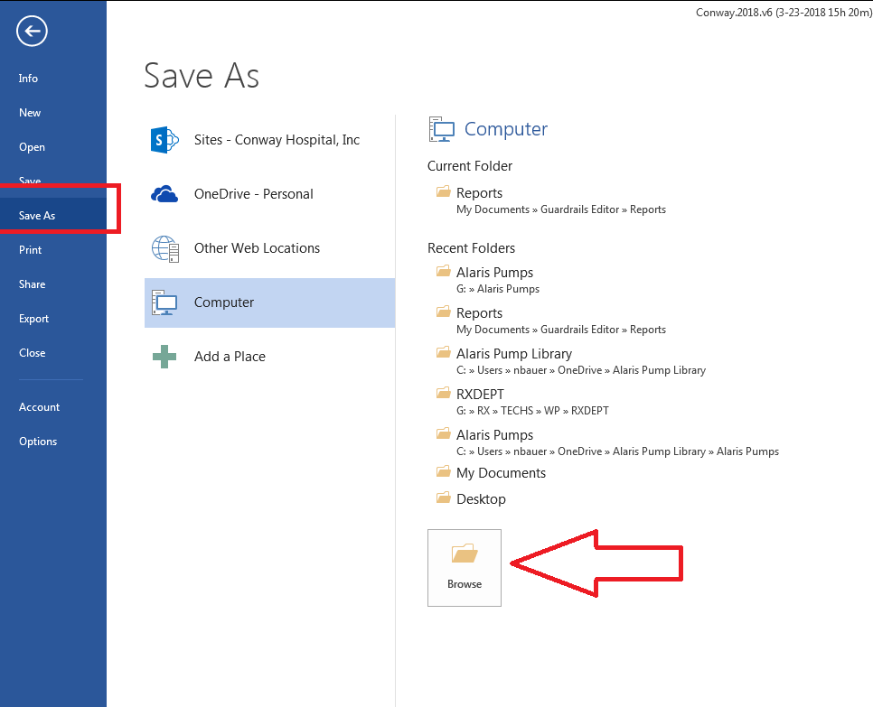

* + 1. Save the Word document to G:\PH\Alaris Pumps

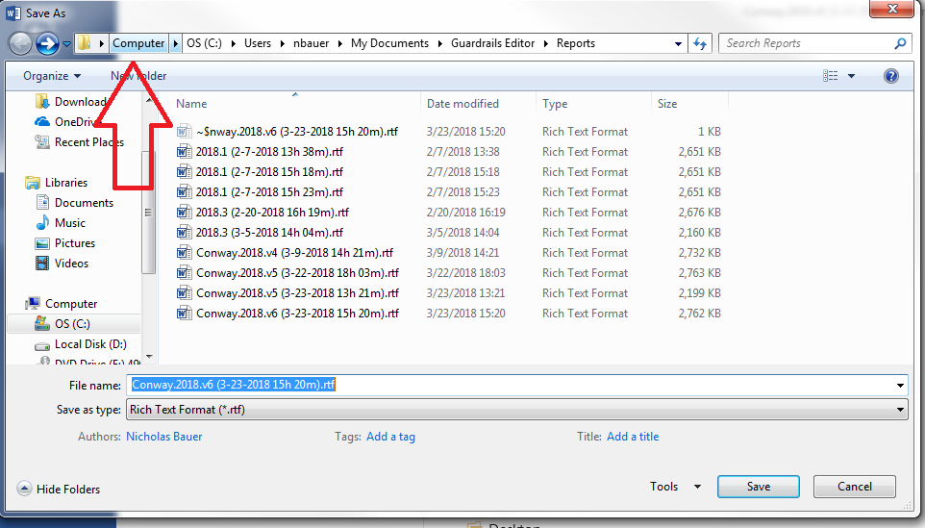

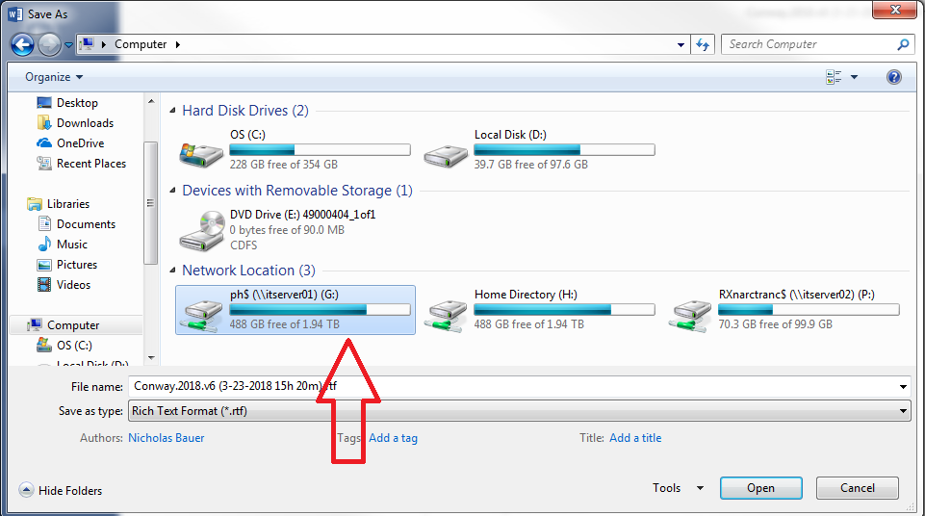

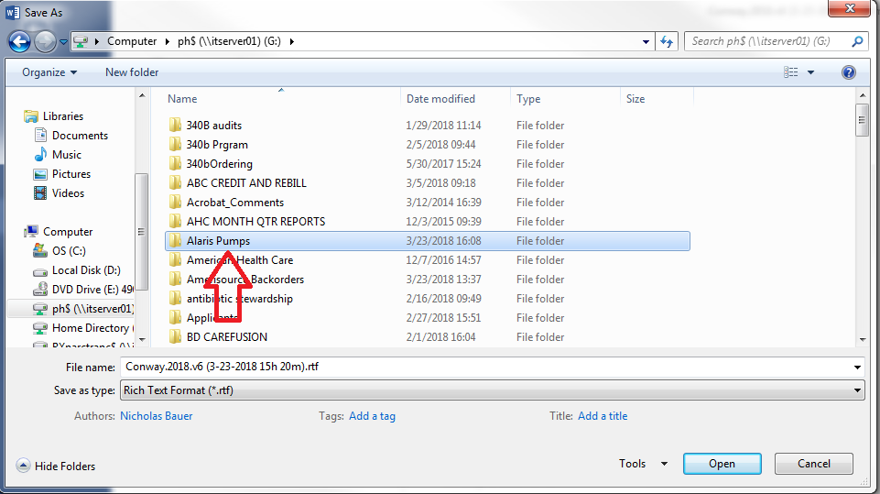

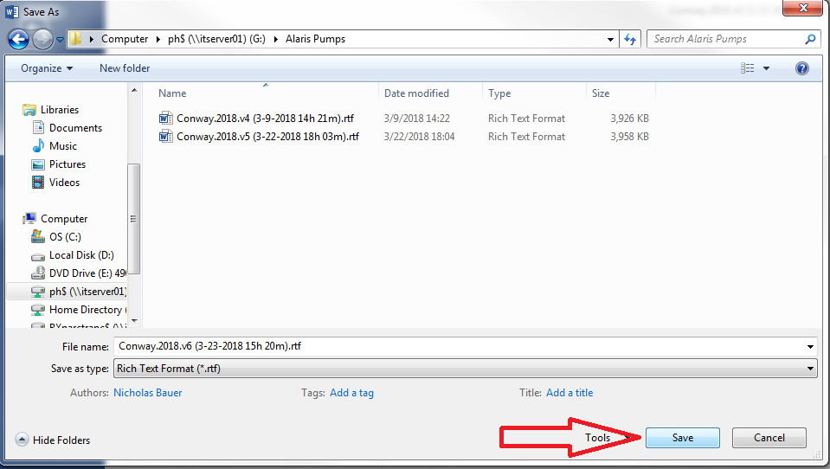

* + 1. Close the Word document once it is saved

1. Back in the Guardrails Editor, click File🡪Release Data Set
2. A password prompt will appear, the password is ‘password’, and click OK
3. Save your data set by either:
   1. Clicking the floppy disk icon in the top left

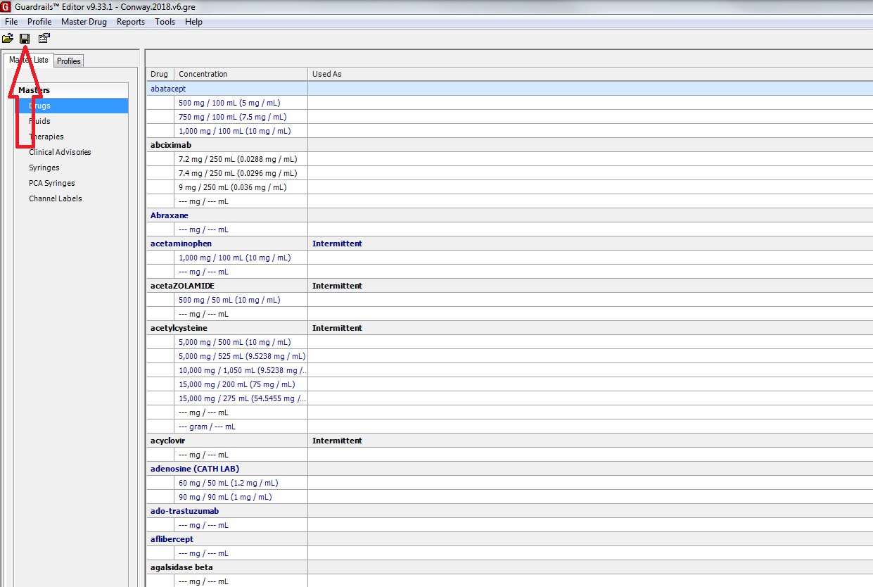

* 1. OR, Click File🡪Save

1. On the G:\PH\ drive, right-click on your new file for your new pump library version, and click Properties

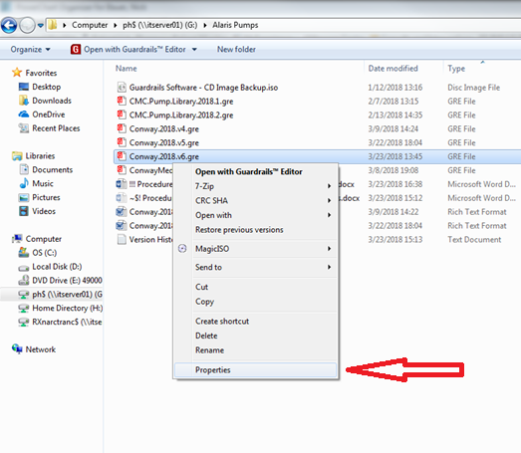

* 1. Check the box marked Read Only, and click OK

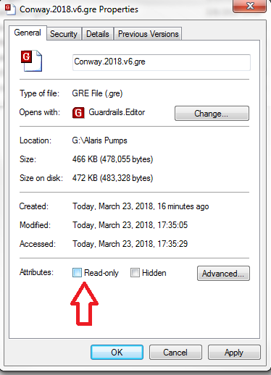

1. In a web browser (INTERNET EXPLORER ONLY), go to: <https://alaris.conwayhospital.com/SystemsManager/Default.aspx>
   1. You may get a warning about the website’s security certificate, click on proceed to website

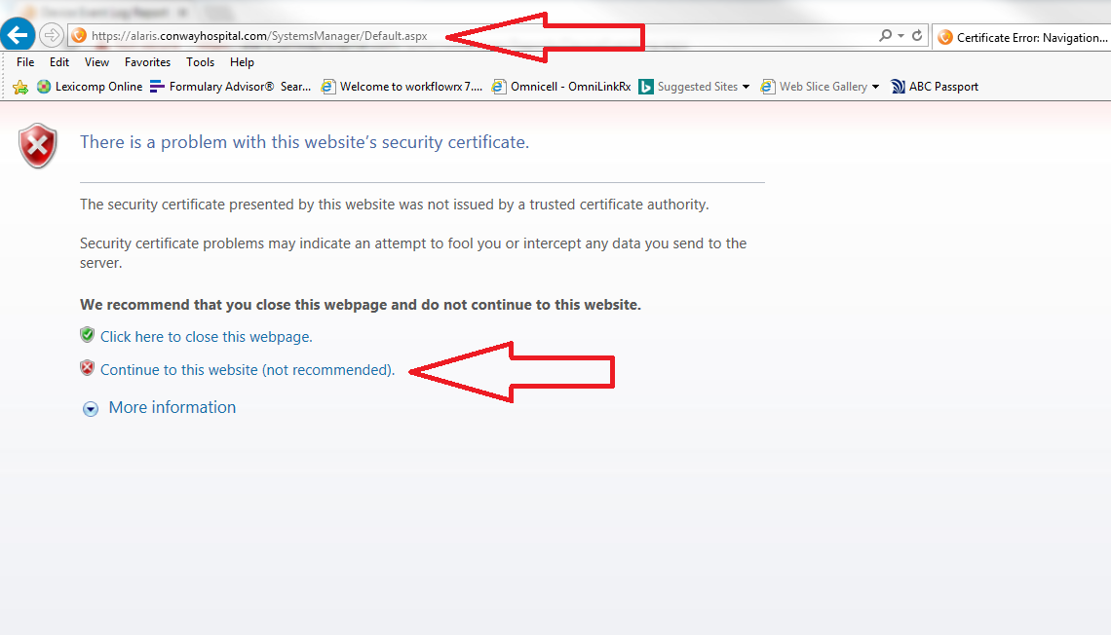

1. Login with your Windows log-in username and password
2. Hover over Data Sets at the top, and click Manage Data Sets

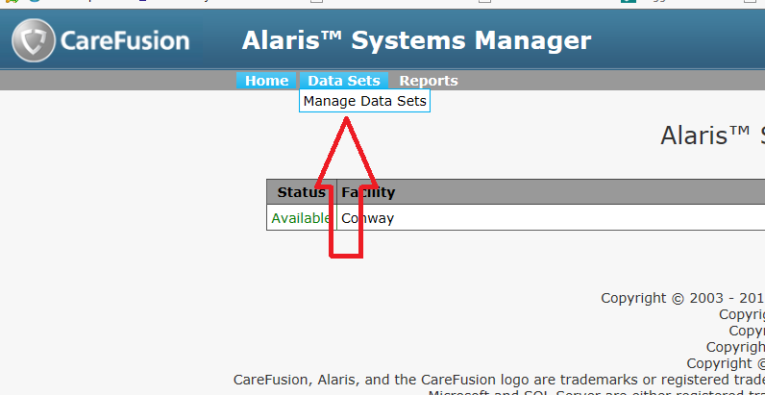

1. Now click Import Data Set

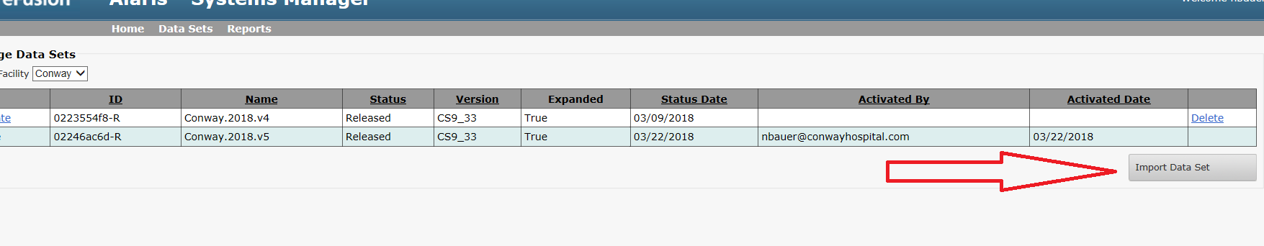

* 1. In the new window that pops up, click Choose File (in Internet Explorer it says Browse…)
  2. 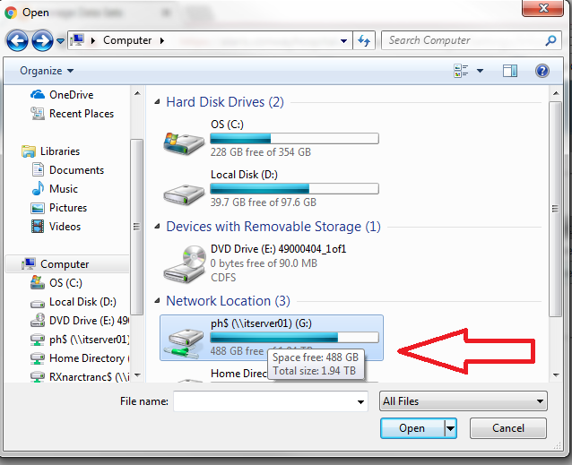Browse to the G:\PH\ drive, and go to the Alaris Pumps folder and click your new pump library file

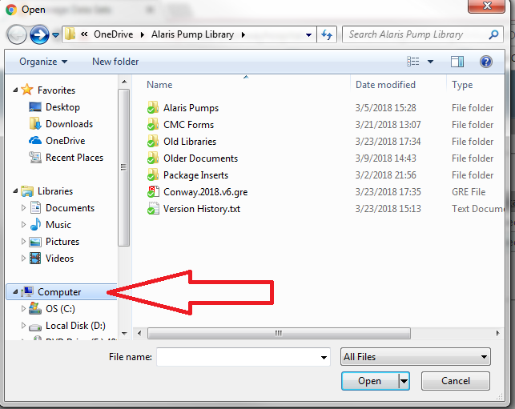

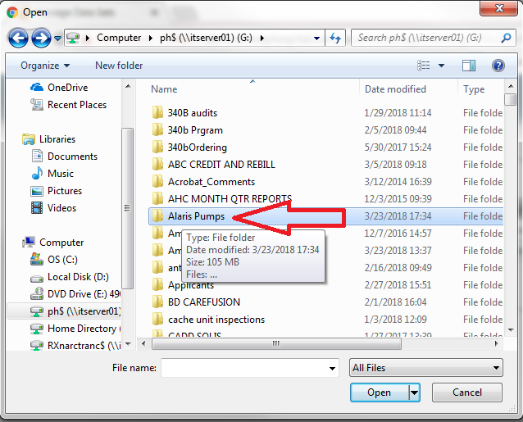

* 1. Once your library is selected, click Import

1. Your library has now been imported, to start transfer to the IV Pumps, click on the Activate button on the left next to your pump library version and your library will be uploaded to the IV pumps

